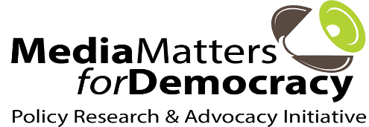 

**Building Resilience: Women human rights defenders and journalists collaborating against gendered misinformation**

**Participant Information Sheet**

|  |  |
| --- | --- |
| ***Name*** |  |
| ***Preferred Pronouns***  ***(will be used for documentation purpose only)*** |  |
| ***Previously Attended International Conferences/Consultations*** |  |
| ***Contact Person (Name, Mobile Number)***  ***(In case of Emergency)*** |  |
| ***WhatsApp or Signal contact number for communication*** |  |
| ***Dietary Requirement/ Food Restrictions/Allergies/medication***  ***(Please Specify)*** |  |
| ***Covid-19 Vaccination Status*** |  |